February 12, 2025

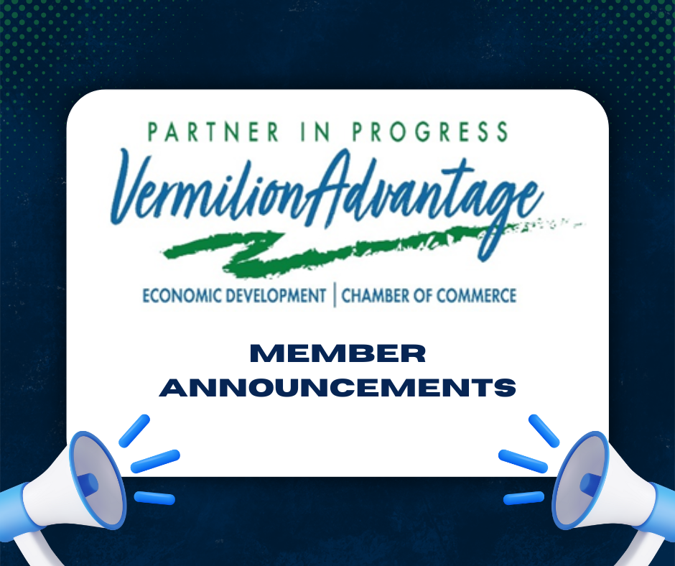

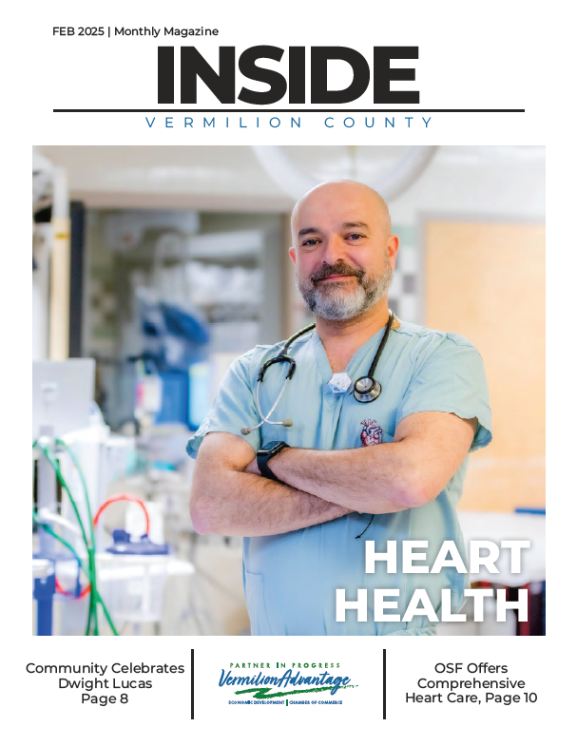

To view this months issues of "Inside Vermilion County" visit our website!
Check out this month's magazine here!







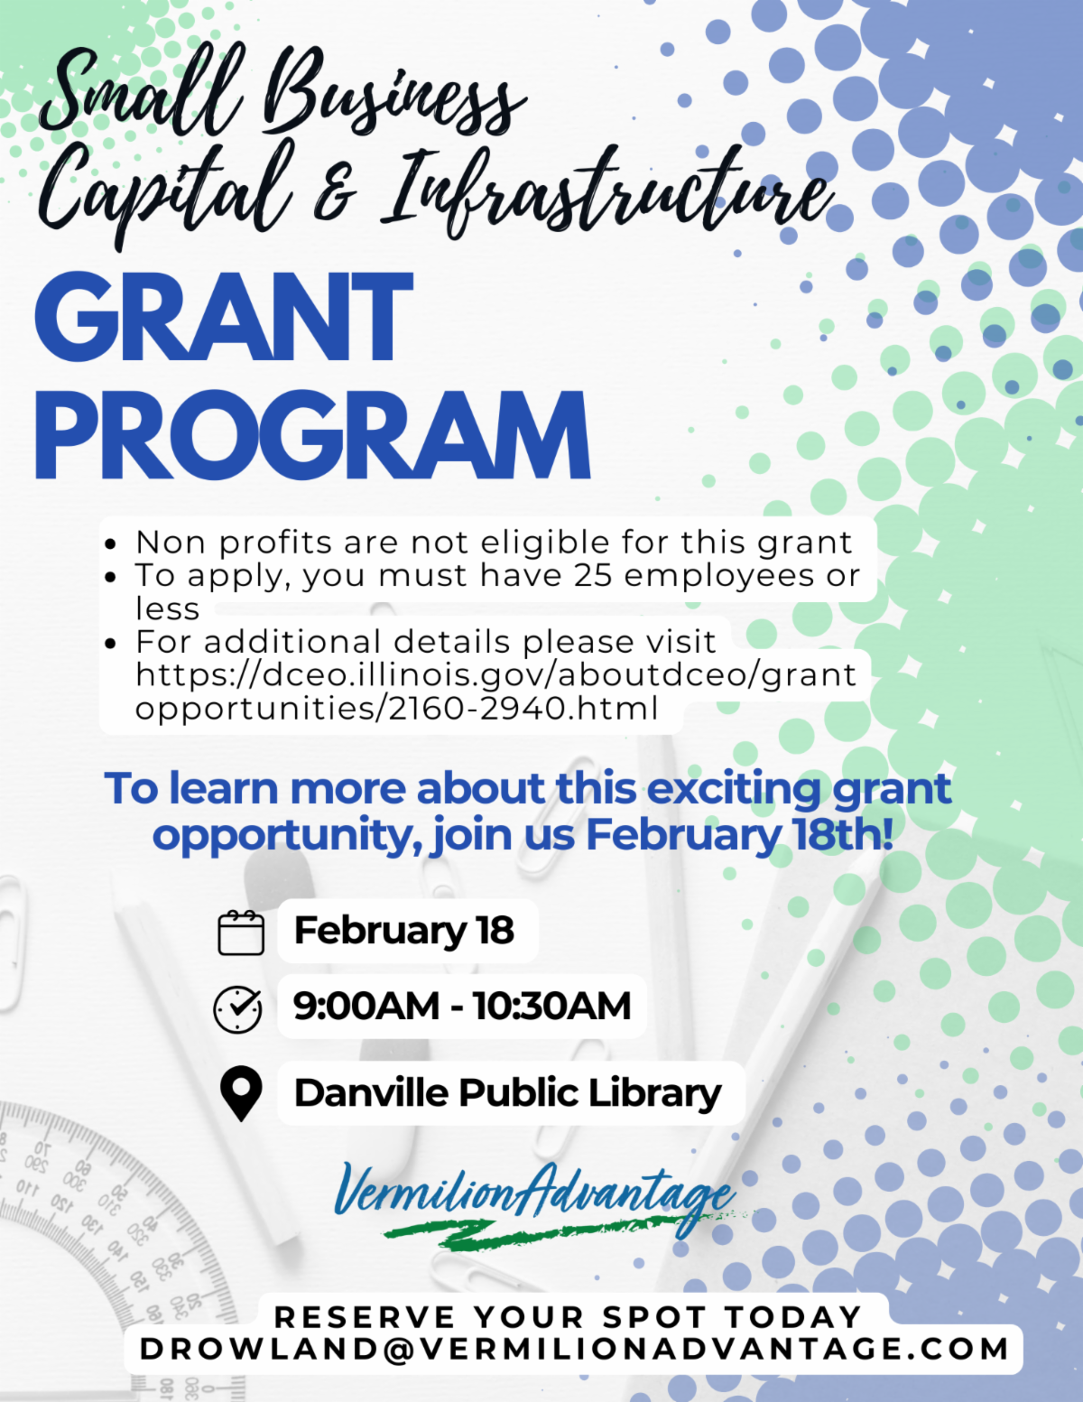





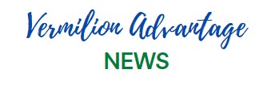

  Jobs
  ﻿
  Vermilion Advantage Job Board - For current, local job opportunities posted directly by employers, please see the Vermilion County Jobs Board at www.vermilionadvantage.com/job-board If you need help to be set up as a user on our Vermilion County Jobs Board page to post job openings, please contact Vermilion Advantage at 217-442-6201.
  ﻿﻿Healthcare
  Two Roads Wellness offering new Recovery Group - see flyer here
  Join the Health & Resource Fair at the Hoopeston Multi Agency - see flyer here
  Education
  DACC Community Ed releases new schedule of classes - find info here
  DACC-Franklin University 3+1 Bachelor's program just got more affordable - see press release here
  Lakeview College of Nursing Scholarships are available - find info here
  Project Success and DACC Partner to Launch After School Music Program at DHS. The program kicks off Jan 29 and will meet twice a week.
  DACC Foundation Scholarship application is now open! Find info here
  Danville Public School Foundation New - see the latest edition here

Announcements & Community

  ﻿Vermilion Advantage is hiring a Workforce Education Director - see job listing here
  Danville Public Library community members now have access to native seeds - see press release here
  IBEW Local 538 now accepting applications - see flyer here
  Danville Art League will feature local artist Lori Learnard on February 16 from 2-4:00PM. Find more information here
  
  Did you know we have a new YouTube Channel? Check it out for all the latest Vermilion Advantage news! Click here and subscribe so you don't miss new content!
  Liberty Estates - Teresa Ross, local performer and actress, will be the guest of honor on Feb. 21 from 3-4 PM. This is a free event, open to the public at Liberty Village of Danville
  Danville Noon Rotary welcomed ultramarathon runner, author, and local history fanatic Michael Kasper. (pictured below with Tonya Hill, President)
  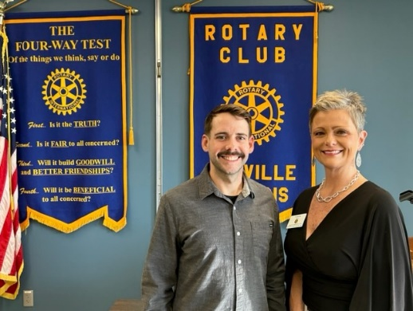
  ﻿East Central Illinois Community Action Agency VOCA Newsletter - see the February newsletter here
  Adecco - see their February Newsletter here
  Vermilion Advantage is excited to share advertising opportunities in Inside Vermilion County magazine! Find more information here
  City of Danville announces 2025 Corporate Memberships - see info here
  Find out about the Illinois Digital Equity Capacity Grant here
  Iron Workers Local Union 380 announces apprenticeship opportunity - find more information here
  Clanin Creative made it to the top 10 in the Illinois State Flag Redesign Contest! To see the design and vote, click here
  Friends of the Kickapoo Rail Trail - check out their new brochure here
  BRBH Media: If you missed open enrollment for the new content retainer services, you still have the option for late enrollment available until 2/28! Don't miss this incredible offer for professional quality content produced for your brand each month of the year!
  Keep Vermilion County Beautiful is hosting their annual membership drive - find more info here
  Survivor Resource Center invites everyone to their 3rd Annual Dancing For the Stars Fundraising event! See event info here and sponsorship info here

Upcoming Member Events

February 14 The Valley of Danville presents: Love Letters - see flyer here

February 14 East Central Illinois Community Action Agency "A Night to Remember" - see flyer here

March 6 Vermilion Valley FCA Victory Dessert - see flyer here

March 7 First Fridays Danville's Got Talent - see flyer here

Danville Farmers Market:
- 9:00AM-1:00PM
- Seven Point Dispensary
Danville Public Library:
- Winter Reading Program: Squishing Through the Snow: Join us for our Squishing Through the Snow Winter Reading Program, running from January 6th to February 17th, 2025! Kids, Tweens, Teens, and Adults can register starting December 30th and earn fun prizes by logging their reading days on the Beanstack app.
- Rubber Ducky Readers: Join this fun Beanstack Challenge! For every 10 books read, the child will get a rubber duck, every 100 books equal a book, a sticker and a certificate, 1000 books equal a goody bag filled with a book, a sticker, a completion certificate, a stuffed animal, a blow-up rubber duck, etc. This challenge is for ages 0-6.
- Diversify Your Reading Challenge: In a reading rut? Expand your reading horizons by completing one or all of our challenges! Finish a challenge to earn a custom poster! This challenge is for teens and adults, ages 13 and up. August 1, 2024 – August 1, 2025
- February 12: Teen Writing Club. Join us every Wednesday for Teen Writing Club! Journals and pens will be provided for our teen writers, along with writing prompts. 4:30 pm - 5:30 pm in the YA area.
- February 12: Wordy Wednesdays. Puzzle lovers, mark your calendars! Every Wednesday, head on up to the 2nd floor Reference Desk for a variety of word puzzles. Available anytime during our regular business hours.
- February 13: Anything Tech for Teens. Introducing teens to some of the library's cool technology, including 3D Printing, 3D Pens, Sphero Balls, Cricut, and a Flight Simulator. Thursdays at 3:00 pm in the Teen Zone.
- February 13: CoHo Snack & Chat. Come ready to chat about your favorite Colleen Hoover book and enjoy cookies*, candy*, and great conversation with fellow fans. It's a great way to spend Galentine's Day! *While supplies last. 5:00-6:00pm in the 2nd Floor Conference Room.
- February 13: Crafty Thursday. Stop by the Teen Zone for 3D Pen Crafting! This week: Marbled Bookmark. Thursday from 4:30 pm to 5:30 pm in the Teen Zone.
- February 15: Goosebumps Parent/Child Book Club. Parents, share your Goosebumps nostalgia with your kids in our Parent-Child Book Club series! This month, we're featuring The Ghost Next Door by R.L. Stine. We'll have activities and you will get to make and enjoy a yummy book-related snack. Each child will get a free copy of the book to take home. 1:00 pm in the Howard Rutan Meeting Room.
- February 15: Sensory and Bilingual Story Adventures. A unique programming experience combining bilingual storytelling with sensory-friendly activities, designed to engage children of all abilities. This inclusive program creates a welcoming space where stories come to life through interactive elements, fostering language development and sensory exploration in a fun and supportive environment. Saturdays at 11 a.m. in the Children’s Department.
David S. Palmer Arena
- Dashers Hockey
- February 14 at 7:00PM vs Athen Rock Lobsters
- February 15 at 7:00PM vs Athen Rock Lobsters
- February 16 at 4:00PM vs Athen Rock Lobsters
Georgetown American Legion Post #203:
- Friday night dinner, 5:00-7:00
- Serving Chicken wings with sides, hosted by the Legionnaires
Golden Nugget Danville:
- 24 Karat Club- All Month/ everyday
- Monthly Birthday Incentives- Visit during your birthday month and receive a free slot play gift, for every tier.
- Tier Status and Annual renewal- Level up instantly and receive a special gift
- 24K celebration Days- Enjoy bonus points, entry multipliers and exclusive parties
- Status Advantage Incentives- Cash advances waived for Chairman and Elite. Complimentary check cashing for Premier, Chairman and Elite.
- Dining Discounts-24k Club discounts on dining ranging from 15%-25%. Enjoy a delicious appetizer for Half Price appetizers Monday-Thursday in Saltgrass
- Monday & Tuesdays - Winter Wonder Pull tabs, 55% off for Golden Gamers 55+ at Front Row
- Wednesdays - Give $10, Get $10 for the Salvation Army
- Every Thursday in Jan and Feb - 24k club members playing on Thursdays between 5:30 and 8:30OM have a chance to win $200 every hour.
- Fridays - Polar Prize Wheel
- Also check out the Front Row Deals while you're there!
Hoopeston Public Library:
- Check out the February events here
Sleepy Creek Vineyards:
- Mondays: Yoga & Wine with Linda every Monday; Doors open at 5:30PM Class begins at 6:00PM, Cost is $10
- Tuesdays: Yoga & Wine with Mandy every Tuesday; Doors open at 5:30PM Class begins at 6:00PM, Cost is $10
- February 13 5:00PM-8:00PM Galentine's Mini Pop-Up
- Fridays: Noon to 10:00PM, 7:00-9:00PM Valentine's with Kolten Taylor
- Saturday: Noon to 7:00PM, 6:00PM Date with Death Murder Mystery Dinner
Snapper's - Turtle Run Golf & Banquet Center:
- Friday nights: All you can eat catfish 5:30-9:00PM
- Saturday nights: All you can eat Indian buffet 5:30-9:00PM
- Now serving breakfast, lunch and dinner daily!
Step Recovery Center:
- Friday nights, 6:00PM-8:00PM Recovery Rocks - Ala-teen Recovery Group
- Meet with other teens (13-17) for fun, fellowship and support
- For questions about events, contact Wendy at 217-597-9653
The Local (Covington)
- Check out their February specials here
Westville American Legion Post 51:
- Wednesdays: Queen of Hearts Drawing at 7:00PM. Tickets $1.00.
- Open Bowl - Fridays and Saturdays 5:00PM-8:00PM
- Fridays: Happy Hour 4-7, buy 1 drink, get 1 for 50% off

